AEGON

Architecture Solution Document

For

Aegon Five9 Implementation

Version 3.0
Date:April 29th 2025
Aegon Enhancement Features
Jordan Steven Chavarria Davila: Architect



Table of Contents
1.0 Document History 4
Revision History 4
Approvals 4
Distribution 5
Contacts 5
Reference Documents 5
Terminology 5
2.0 Introduction 8
Overview 8
Impact on User Experience 8
Purpose of this document 8
Document Scope 8
3.0 Requirements 9
Aegon Requirements 9
Functional Requirements 9
Security Requirements 9
Non-Functional Requirements 10
4.0 System Context 11
Overview 11
System Context Diagram 11
List of Flows 11
5.0 Architectural Overview 13
Logical Level Overview 13
Data and Security 14
Operational Model Diagram 16
Process Steps Overview 17
Use Case 18
6.0 Architectural Decisions 28
Decisions Summary 28
Architectural Decision AD01 29
Architectural Decision AD02 30
Architectural Decision AD03 31
Architectural Decision AD04 32
Architectural Decision AD05 33
Architectural Decision AD06 34
Architectural Decision AD07 35
Architectural Decision AD08 36
7.0 Component Model 37
8.0 SN API Endpoint and Data 42
Operation: Trigger Azure Radius Authentication 42
Operation: Get User Sys_id 42
Operation: Create Interaction 43
Operation: Get Incident list 43
Operation: Get Incident 44
Operation: Get Additional Comments 44
Operation: Get Assignment Group 45
Access Control Lists 45
9.0 Deployment Model 47
10.0 Technology Components 48

Document History
This is a snapshot of an on-line document. Paper copies are valid only on the day they are printed. Refer to the author if you are in any doubt about the currency of this document.

Revision History
Revision Number | Revision Date | Summary of Changes | Changes marked
1.0 | 01/24/24 | Initial Draft | N
1.1 | 02/01/24 | Formatted tables and renamed document | N
1.2 | 02/06/2024 | Reviewed by Aegon | Y
1.3 | 02/06/2024 | Added comments to document from Aegon | N
1.4 | 02/06/2024 | Updated Tables | N
1.5 | 02/08/2024 | Rework the version based on the feedback | N
1.6 | 02/12/2024 | Rework the version based on internal review | N
1.7 | 02/28/2024 | Rework the version based on Aegon feedback | N
1.8 | 03/05/2024 | Added authentication process to document | N
1.9 | 03/08/2024 | Rework the version based on Aegon feedback | N
1.10 | 03/12/2024 | Rework the version based on Aegon feedback | N
2.0 | 04/02/2024 | Reworked to add Appendix | N
2.1 | 04/05/2024 | Added Network information to Appendix | N
2.2 | 05/03/2024 | Changes related to email authentication | N
2.3 | 05/10/2024 | Rework the version based on Aegon feedback | N
2.4 | 11/12/2024 | Rework the version based on Aegon feedback | N
2.5 | 04/02/2025 | CMBD Table added | N
2.6 | 04/14/2025 | Regular Security Process and Third-party contractor for Major Incident Process | Y
2.7 | 04/23/2025 | Password reset live additional authentication | Y
3.0 | 04/29/2025 | ASD Approved in ARB | Y

Approvals
This document requires following approvals:
Name | Title
Mirza Baig | Account Chief Architect

Distribution
This document has been distributed to the above Approvers, and to:
Name | Title
 | Delivery Architecture
 | Service Delivery Manager
 | Account Portfolio Manager
 | Integration Architect

Contacts
Key contacts for this area are:
Name | Role
Jordan Steven Chavarria Davila | Solution Architect
Johnny Sokhn | Solution Architect

Reference Documents
Software Platforms | Author | Source
Five9 | Five9 | https://documentation.five9.com/en-us/home.htm
Studio 7 | Five9 | https://docs.studioportal.io/Content/studio-combo/landing-studio-combo.htm
DialogFlow | Google | https://cloud.google.com/dialogflow/docs
SN | SN | https://docs.servicenow.com/
ICCC Technical Documentation AEGON-Final version 1.0 | Kyndryl

Terminology
Term or Acronym | Description
AEG | Aegon LLC
AD | Microsoft Active Directory
ARB | Architecture Review Board
BU | Business Unit
CP | Control Plane: application used to manage automation deployment of VDI’s
DR | Disaster Recovery: the ability to restore an application to a date specified.
DRES | Dedicated Resource Segment of Networking
DIMM | Dual In-Line Memory Module
Endpoint | A configured resource designed and managed by client or a third-party entity.
FC | Fiber Channel
Frame | A generic term used to describe a single E870 system within the overall utility
GTS | Global Technical Services: AEG BU
HA | High Availability: the of an application to survive a single failure and continue functioning in a degraded state.
Host | A physical server running some kind of virtualization hosting system (e.g. Power VM, ESXi)
HBA | Host Bus Adapter. In the context of this document the HBA refers to the physical adapter(s) which connect the computer to the Storage Area Network (SAN) infrastructure.
HMC | Hardware Management Console
INF | Infrastructure/Shared
LAN | Local Area Network
LOB | Line-Of-Business,
LPAR | Logical Partition, or workload.
LPAR2RRD | A web based monitoring tool which displays detailed processor utilization data at the frame level.
LPM | Live Partition Mobility
LUN | Logical Unit (Number)
MPLS | Multi-protocol Label Switching (MPLS) is a mechanism in high-performance telecommunications networks which directs and carries data from one network node to the next with the help of labels. MPLS makes it easy to create "virtual links" between distant nodes. It can encapsulate packets of various network protocols.
MSP | Mover Service Partition
NPIV | N-Port ID Virtualization: The technology used to allow multiple virtual fiber nodes to share a single physical fiber port.
OS | Operating System
POC | Proof Of Concept
pUtility | “Power Utility”. A generic term used to describe all of the E870 systems and their constituent supporting infrastructure.
RTO | Recovery Time Objective
RMC | Remote Management & Control. The connectivity flow used in VIOS and HMC communications.
SA | System Administrator
SAN | Storage Area Network
SEA | Shared Ethernet Adapter.
SLA | Service Level Agreement
SME | Subject Matter Expert
SOP | Standard Operating Procedures
SPP | Shared Processor Pool
SRM | System Resource Manager for Capacity Planning
STL | St. Louis, MO KYNDRYL datacenter
TSM | Tivoli Storage Manager – now known as Spectrum Protect
VIOS | Virtual I/O Server: This is the main KYNDRYL PowerVM component which manages the virtualization of workload I/O (Network and Storage)
VLAN | Virtual Local Area Network
VM | Virtual Machine
WWPN | World Wide Port Name: The standard for a unique 64-bit Identifier for hardware fiber ports (HBA Ports).
ICCC | Intelligent Cloud Contact Center
SN | ServiceNow
IVR | Interactive Voice Response
CTI | Computer Telephony Integration
DWS | Digital Workplace Services
MFA | Multi Factor Authentication
NLP | Natural Language Processing
API | Application Programming Interface
CSM | Customer Service Management
UAT | User Acceptance Testing
Inference | Equivalent to Studio 7 (same platform)

Introduction

Overview
The solution focuses on leveraging and integrating the capabilities of the Five9 ICCC and Studio with SN, Google Dialog Flow for automating voice channel services. Identifying and authenticating the user will open additional channels and service avenues, providing an enhanced user experience. To authenticate the user the IVR will use an authentication method through Azure Radius and Microsoft Authenticator App.
The primary objective is to improve user experience and streamline service processes by integrating advanced functionalities into our IVR system and CTI capabilities.

Impact on User Experience
The solution proposed aims to enhance user experience by integrating various technologies such as Five9 ICCC, Studio, Google Dialog Flow and SN. The primary goal is to streamline service processes through advanced functionalities in the IVR. By leveraging these technologies, users will benefit from personalized interactions, automated service requests, and seamless access to relevant information. Key functional requirements include user identification, personalized greetings, dynamic intent recognition, previous interaction history retrieval, ticket status checking, and ticket creation options. The integration also emphasizes security, compliance, and data privacy considerations. Overall, the integration promises to elevate user satisfaction and efficiency in accessing and resolving service-related issues.

Purpose of this document
The overall solution described in this document is a managed service offering provided by KYNDRYL Global DWS. This document outlines the platform architecture for integrating Voice with Five9, Studio, Google Dialog Flow and SN. It also documents the solution design necessary for deploying and implementing this integration to customer accounts. The integration comprises several reusable Five9 VCC Foreign scripts, in addition to multiple Voice Tasks that integration engineers can customize for implementation in various accounts.

Document Scope
This document will describe integration of Voice with Five9, Studio, Google Dialog Flow and SN, infrastructure architecture and deployment patterns, Operations & Management considerations.
The document also describes Security & Compliance, Network Connectivity and Data Security/Privacy of the solution.

Requirements

Aegon Requirements

Functional Requirements
- FR01 – The IVR will identify the user based on User ID located within the SN profile, the user will provide his User ID spelling it either phonetically, letter by letter or a combination of phonetic and letters.
- FR02 – The IVR will authenticate the user through Azure Radius sending a push notification to the cellphone and expecting a response of true (Approved) or false (Denied or Request time out).
- FR03 – The IVR will greet the caller by name after the identification process.
- FR04 – Based on user utterances, the IVR will communicate with Google Dialogflow to dynamically identify intents and entities and automate the following use cases: Password Reset, Virtual Machine Issue, VPN Issue, Ticket Status, and MFA Issue. All utterances have already been provided by the Aegon Service Desk.
- FR05 – The IVR will check if the user has called before, if the call occurred within a specified number of days, and if the agent who spoke with the user before is available. If all three parameters are true, the user will be offered the option to speak with the same agent.
- FR06 – The IVR will fetch information from the incident table using the SN API and provide the user with the option to check the status of the selected ticket. Details such as Ticket Number, Assignment Group, Status, On-Hold Reason, Additional Comments, and Description will be provided. Users can check the status of their latest five tickets based on the following states: new, on hold, in progress, and resolved.
- FR07 – The IVR will provide the option for the user to create an interaction ticket using the SN API, the short description will be set automatically to the intent captured from the utterance from the user and a long description (comprising additional details provided by the user).
- FR08 – The IVR will provide relevant information to the agent regarding the caller, such as first name, last name, phone number, the interaction ticket number created, authentication status (true or false) and the incident ticket status number in case the caller fetched it during the call flow.

Security Requirements
- SR01 – Access to the API Gateway with Cognito OAuth2 developed by Aegon to access SN.
- SR02 – HTTPS (TLS 1.2) and WebSocket connections are the standard security protocols used to communicate between SN and the IVR (Five9 environment).
- SR03 – An Authorization Profile will be created within the Auth Profile repository in the IVR (Studio 7) to manage Aegon Cognito access token. The stored password is not readable once entered; this includes not being able to retrieve the password value programmatically from IVR scripts.
- SR04 – Web traffic is always encrypted in transit using TLS 1.2, while voice traffic can be encrypted in transit through SRTP.
- SR05 – Voice recordings are encrypted during transit through SFTP and while at rest using AES 256-bit encryption.
- SR06 - The system undergoes Periodic vulnerability scanning.

Non-Functional Requirements
- NFR01 - Each application accessing ServiceNow via API Gateway must use a unique, dedicated service account. ServiceNow will assign application-specific ACLs to these accounts, ensuring that only required permissions are granted. API Gateway will use roles to further secure and restrict each service account’s access to align with application needs.
- NFR02 – The Kyndryl service desk will continue using the Five9 Agent Desktop. The Kyndryl service desk will not be utilizing the Five9 adapter within SN.
- NFR03: It is preferable for the system to support Citrix Virtual Apps and Desktops version 1912 LTSR CU3, or a later compatible version.
- NFR04: Preferably, the system should utilize Microsoft Windows Desktop 10 or a newer version that meets the system requirements.
- NFR05: It is preferred that the system integrates with Citrix Workspace 2019 (formerly Citrix Receiver) or a more recent version.
- NFR06: Preferably, the system should support Citrix ICA and HDX protocols, or other comparable protocols for efficient remote access and multimedia streaming.
- NFR07 - Support GDPR and other local country / geography regulations in addition to Kyndryl policies.
- NFR08 - There must be separately defined roles and privileges between system consumers and the system administrators.

System Context

Overview
The diagram illustrates the interaction flow between the user, the IVR System (Five9 and Studio 7), SN, and Google DialogFlow. The IVR system serves as the intermediary between the user, the backend system, and the agent. It facilitates various tasks such as user identification, call handling, ticket management, and interaction with Google DialogFlow for intent handling and automation. Additionally, the IVR system allows the user to interact with an agent through the Five9 Agent Desktop.

System Context Diagram
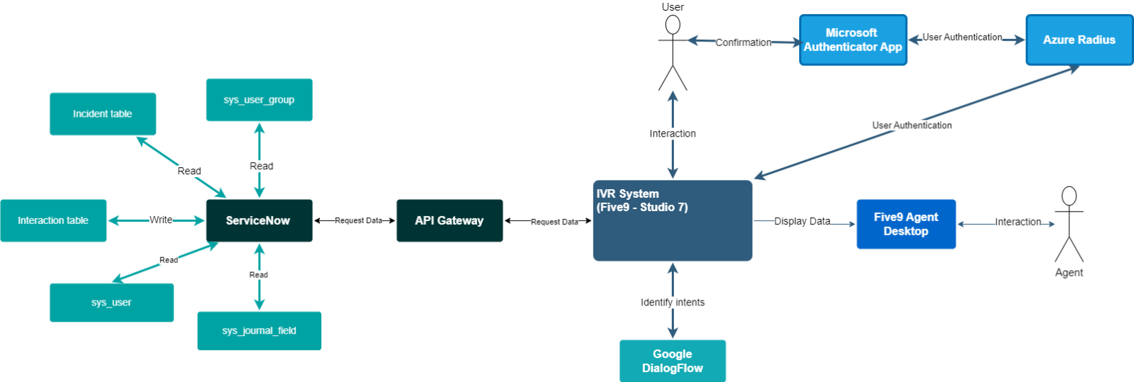
Figure 1 – System Context Diagram

List of Flows
Flow Description | Flow Source | Flow Destination
User interaction with IVR system | User | IVR System
IVR system interaction with SN for user identification (all interaction to SN goes through the API Gateway) | IVR System | SN
IVR system interaction with SN to create tickets (Type: Interaction) (all interaction to SN goes through the API Gateway) | IVR System | SN
IVR system interaction with SN to fetch incident tickets (all interaction to SN goes through the API Gateway) | IVR System | SN
IVR system interaction with Google DialogFlow for intent handling and automation | IVR System | Google DialogFlow
IVR system providing caller information to agents | IVR System | Five9 Agent Desktop
IVR system will authenticate the user based on the response of the push notification sent through Azure Radius to the Microsoft Authenticator App. | IVR System | Azure Radius

Architectural Overview
The proposed solution is a comprehensive IVR system designed to efficiently handle user inquiries and tasks related to SN, as well as automate multiple use cases.

Logical Level Overview
- User Interaction:
- Users interact with the IVR system via phone calls, identifying themselves and providing voice commands and responses to prompts.
- Azure Radius Authentication:
- Once the user has confirmed their User ID, the IVR will send an API request having the following 3 headers: username (User ID captured from the user in the identification), domain (static value set to us), mfamethod (static value set to azure), the request will trigger a push notification through the cellphone for the user to approve or deny, based on the option selected by the user, the API request will get a response of true or false. The user must have their default sign-in method selected in their Security Info at https://mysignins.microsoft.com/security-info. This process is documented in KB0015353. Additionally, a Standard Operating Procedure (SOP) has been provided to the Service Desk to outline any extra steps required to handle this scenario effectively.
True: The user has approved the push notification in the cellphone.
False: The user has denied the push notification, or the request has time out.
- If an Aegon user is not authenticated through the automated process, the regular authentication process will be followed.
- Third-party contractors calling about a major incident and who do not have MFA set up will be transferred to an available agent to complete the regular security verification.
- In an attempt to combat social engineering attacks or MFA fatigue techniques, every Aegon user calling to reset their password, will go through live authentication with the agent regardless of automated authentication outcome.
Acknowledgement of a requirement for additional hardening solution around such exploits is notated and an improvised solution to monitor and report such attempts will be explored in addition to live authentication.
- IVR System:
- The IVR system serves as the central component of the solution, managing user interactions and facilitating communication with external systems. It includes functionalities to identify users based on their SN profile, greet callers by name, dynamically provide options based on user utterances, and automate the following use cases: Password Reset, Virtual Machine Issue, VPN Issue, Ticket Status, and MFA Issue. All utterances have already been provided by the Aegon Service Desk, and it also checks for the availability of the last agent that the user reached previously.
- SN Integration:
- The IVR system integrates with SN to access user profiles, retrieve incidents, and generate interaction tickets.
- It retrieves information such as ticket status, assignment group, on-hold reason, additional comments, and description. Consequently, users can check the status of their incident tickets. Users can check the status of their latest five tickets based on the following states: new, on hold, in progress, and resolved.
- Users will create an interaction ticket by providing a long description (comprising additional details provided by the user) and the short description will be set automatically to the intent detected (Password Reset, Virtual Machine Issue, VPN Issue, Ticket Status, and MFA Issue) prior to transfer the call to a live agent for assistance.
- Google DialogFlow Integration:
- The IVR system utilizes Google Dialogflow to dynamically identify intents and entities and automate the call flow. This integration enhances the IVR system's capabilities by enabling natural language understanding and automated responses.
- Agent Integration:
- The IVR system provides relevant caller information to agents through the Five9 Agent Desktop, including first name, last name, phone number, interaction ticket number created, authentication status and incident ticket status number if the caller fetched it during the call flow. This ensures seamless communication between the IVR system and live agents, enhancing customer service and issue resolution.
- Overall Functionality:
- The proposed solution aims to streamline user interactions, improve service delivery, and enhance efficiency in handling call flows.
- It provides a user-friendly interface, leverages automation where possible, and integrates seamlessly with existing systems such as SN and Google Dialogflow.

Data and Security

  - Data Storage in Five9:
- Data Privacy: PII data is retrieved from SN and processed to temporarily display user-related information to the agent in the Five9 Agent Desktop window. This data is not stored in Five9 once the agent-user session is completed. Only the incoming phone number data is stored in the call history table in Five9; this is not stored/paired with any other PII data.
- User utterances are being stored temporarily for up to 3 months in Five9 datastore to improve the response efficiency with NLP and Speech-To-Text.
  - Usage of Dialogflow:
- Our interaction with Google Dialogflow is solely for the purpose of analyzing user inputs to determine intents and entities. Only the utterance for this analysis is transmitted, maintaining user privacy and data security.
  - Plugin-Free Implementation:
- Our integration with SN does not require the installation of additional plugins.
  - Call Recording
- This functionality will remain unchanged for the duration of this implementation. No additions or modifications pertaining to call recording are within the scope of this project.

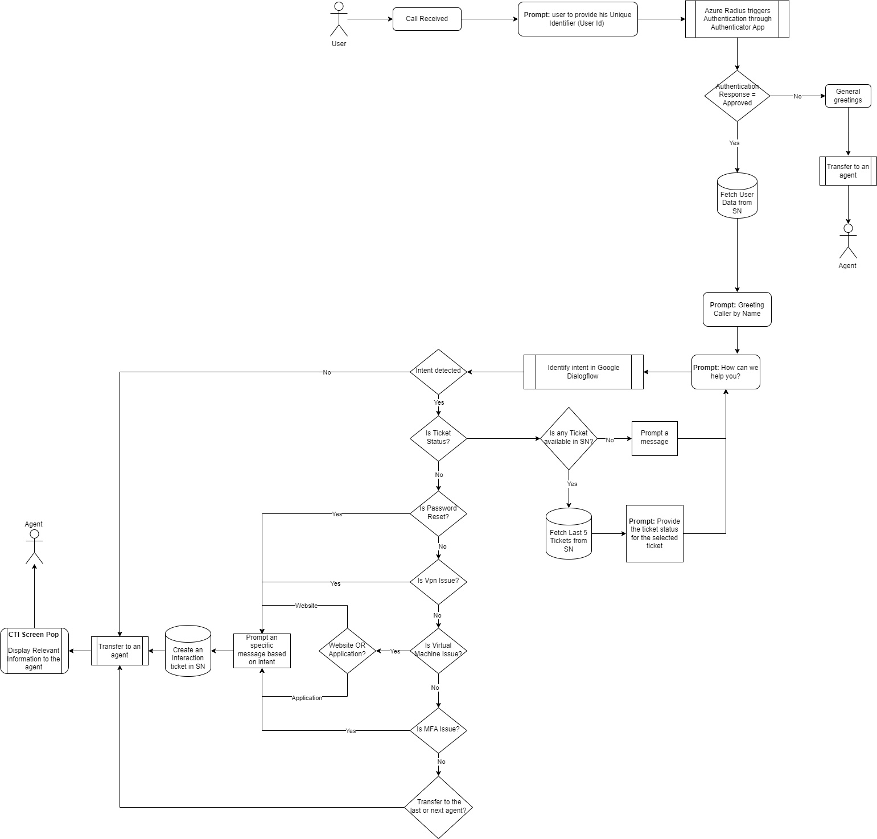
Operational Model Diagram

Figure 2 – System Context Diagram
*Numbers does not reflect the actual flow

Process Steps Overview
1. User Identification:
- The IVR system utilizes the User ID located within the SN profile to identify the user.
2. Azure Radius Authentication:
- Once the user has confirmed their User ID, the IVR will send an API request having the following 3 headers: username (User ID captured from the user in the identification), domain (static value set to us), mfamethod (static value set to azure), the request will trigger a push notification through the cellphone for the user to approve or deny, based on the option selected by the user, the API request will get a response of true or false.
True: The user has approved the push notification in the cellphone.
False: The user has denied the push notification, the request has timed out or if the user does not have the push notification as default sign-in method.
3. Caller Greeting:
- After identifying the user, the IVR system greets the caller by name.
4. Communication with Google Dialogflow:
- Based on user utterances, the IVR system communicates with Google Dialogflow to dynamically identify intents and entities.
- The identified intents are used to automate various use cases, including Password Reset, Virtual Machine Issue, VPN Issue, Ticket Status, and MFA Issue.
5. Intent Detection and Actions:
- If an intent is not detected, the IVR system transfers the call.
- For specific intents:
- Password Reset: Prompts a message, creates an interaction ticket, and transfers the call.
- VPN Issue: Prompts a message, creates an interaction ticket, and transfers the call.
- Virtual Machine Issue: Prompts a message, creates an interaction ticket, and transfers the call.
- MFA Issue: Prompts a message, creates an interaction ticket, and transfers the call.
- Transfer to Agent: Checks previous calls and agent availability. Offers the option to speak with the same agent if conditions are met; otherwise, connects with any available agent.
6. Ticket Status Inquiry:
- For the ticket status intent, the IVR system fetches information from the incident table using the SN API.
- It provides the user with the option to check the status of the selected ticket, including Ticket Number, Assignment Group, Status, On-Hold Reason, Additional Comments, and Description.
7. Interaction Ticket Creation:
- Before transferring a call, the IVR system creates an interaction ticket using the SN API.
- This ticket serves to log the interaction for tracking purposes.

8. Agent Information Provision:
- Once transferred, the IVR system provides relevant information to the agent regarding the caller.
- Information includes the caller's first name, last name, phone number, the interaction ticket number created, if the user was authenticated and the incident ticket status number if it was fetched during the call flow.

Use Case
    - Use Case: Azure Radius Authentication
Actors: User, IVR System, Azure Radius, Microsoft Authenticator App
Preconditions:
The user is identified with User ID in the SN profile.
The user needs to allow in the Microsoft Authenticator App the option to receive push notification.
Basic Flow:
- User Identification:
  - The IVR system utilizes the User ID entered by the user.
- Authentication:
- Push notification is sent to the user cellphone.
- Users tap on approve on the authentication pop up.

- Caller Greeting: After identified and authenticated the user, the IVR system greets the caller by name.
Postconditions:
The user's is prompted to identify the correct support channel for further assistance.
Exceptional Flows:
- If the user taps on deny for the authentication pop up, the interaction would be transfer to the next available agent. Agent will be notified that authentication was not successfully completed
- If the user does not click on either Approve or Deny the request will time out and the interaction would be transfer to the next available agent. Agent will be notified that authentication was not successfully completed

    - Use Case: Password Reset.
Actors: User, IVR System, Google Dialogflow, SN.
Preconditions:
The user is identified with User ID in the SN profile.
User has been authenticated.
The user utterance returns an intention for password reset.
Basic Flow:
- User Identification and Authentication:
  - The IVR system utilizes the User ID located within the SN profile to identify the user.
  - The user will be authenticated through Azure Radius.
- Caller Greeting:
  - After identifying the user, the IVR system greets the caller by name.
- Communication with Google Dialogflow:
  - Based on user utterances, the IVR system communicates with Google Dialogflow to dynamically identify intents and entities.
  - Google Dialogflow identifies the Password Reset intent.
- Intent Detection and Actions:
  - If an intent is not detected or it's not related to Password Reset, the IVR system transfers the call to any available agent.
- For the Password Reset intent: A. The IVR system prompts an informative message B. The IVR system generates an interaction ticket in SN to document the problem, the short description will be set automatically to the intent captured from the utterance from the user and a longer description will be asked to the user C. The IVR system transfers the call to the Customer Service Center – GTS to address the issue further.
- Postconditions:
- The user's call is transferred to the Customer Service Center – GTS support channel for assistance.
Exceptional Flows:
- If the user fails to provide enough information for the IVR system to identify the intent, it prompts the user to repeat or clarify their request.
- If an intent is not properly identified, the call will be transferred to any available agent for assistance.

    - Use Case: VPN Issues.
Actors: User, IVR System, Google Dialogflow, SN.
Preconditions:
The user is identified with User ID in the SN profile.
User has been authenticated.
The user utterance returns an intention for VPN Issues.
Basic Flow:
- User Identification and Authentication:
  - The IVR system utilizes the User ID located within the SN profile to identify the user.
  - The user will be authenticated through Azure Radius.
- Caller Greeting:
  - After identifying the user, the IVR system greets the caller by name.
- Communication with Google Dialogflow:
  - Based on user utterances, the IVR system communicates with Google Dialogflow to dynamically identify intents and entities.
  - Google Dialogflow identifies the VPN Issues intent.
- Intent Detection and Actions:
  - If an intent is not detected or it's not related to VPN Issues, the IVR system transfers the call.
- For the VPN Issues intent: A. The IVR system prompts an informative message B. The IVR system generates an interaction ticket in SN to document the problem, the short description will be set automatically to the intent captured from the utterance from the user and a longer description will be asked to the user C. The IVR system transfers the call to the Customer Service Center - GTS to address the issue further.
- Postconditions:
- The user's call is transferred to the Customer Service Center – GTS support channel for assistance.
Exceptional Flows:
- If the user fails to provide enough information for the IVR system to identify the intent, it prompts the user to repeat or clarify their request.
- If an intent is not properly identified, the call will be transferred to any available agent for assistance.

    - Use Case: Virtual Machine Issue.
Actors: User, IVR System, Google Dialogflow, SN.
Preconditions:
The user is identified with User ID in the SN profile.
User has been authenticated.
The user utterance returns an intention for Virtual Machine Issue.
Basic Flow:
- User Identification and Authentication:
  - The IVR system utilizes the User ID located within the SN profile to identify the user.
  - The user will be authenticated through Azure Radius.
- Caller Greeting:
  - After identifying the user, the IVR system greets the caller by name.
- Communication with Google Dialogflow:
  - Based on user utterances, the IVR system communicates with Google Dialogflow to dynamically identify intents and entities.
  - Google Dialogflow identifies the Virtual Machine Issue intent.
- Intent Detection and Actions:
  - If an intent is not detected or it's not related to Virtual Machine Issue, the IVR system transfers the call.
- For the Virtual Machine Issue intent: A. The IVR will make a secondary question to determine if the issue is related to access through the website or application B. The IVR system prompts an informative message C. The IVR system generates an interaction ticket in SN to document the problem, the short description will be set automatically to the intent captured from the utterance from the user and a longer description will be asked to the user D. The IVR system transfers the call to the Customer Service Center – GTS to address the issue further.
- Postconditions:
- The user's call is transferred to the Customer Service Center – GTS support channel for assistance.
Exceptional Flows:
- If the user fails to provide enough information for the IVR system to identify the intent, it prompts the user to repeat or clarify their request.
- If an intent is not properly identified, the call will be transferred to any available agent for assistance.

  - Use Case: MFA Issue.
Actors: User, IVR System, Google Dialogflow, SN.
Preconditions:
The user is identified with User ID in the SN profile.
User has been authenticated.
The user utterance returns an intention for MFA Issue.
Basic Flow:
- User Identification and Authentication:
  - The IVR system utilizes the User ID located within the SN profile to identify the user.
  - The user will be authenticated through Azure Radius.
- Caller Greeting:
  - After identifying the user, the IVR system greets the caller by name.
- Communication with Google Dialogflow:
  - Based on user utterances, the IVR system communicates with Google Dialogflow to dynamically identify intents and entities.
  - Google Dialogflow identifies the MFA Issue intent.
- Intent Detection and Actions:
  - If an intent is not detected or it's not related to MFA Issue, the IVR system transfers the call.
- For the MFA Issue intent: A. The IVR system prompts an informative message B. The IVR system generates an interaction ticket in SN to document the problem, the short description will be set automatically to the intent captured from the utterance from the user and a longer description will be asked to the user C. The IVR system transfers the call to the Customer Service Center – GTS to address the issue further.
- Postconditions:
- The user's call is transferred to the Customer Service Center – GTS support channel for assistance.
Exceptional Flows:
- If the user fails to provide enough information for the IVR system to identify the intent, it prompts the user to repeat or clarify their request.
- If an intent is not properly identified, the call will be transferred to any available agent for assistance.

- Use Case: Ticket Status.
Actors: User, IVR System, Google Dialogflow, SN.
Preconditions:
The user is identified with User ID in the SN profile.
User has been authenticated.
The user utterance returns an intention for Ticket Status.
The user has incident tickets available to fetch.
Basic Flow:
- User Identification and Authentication:
  - The IVR system utilizes the User ID located within the SN profile to identify the user.
  - The user will be authenticated through Azure Radius.
- Caller Greeting:
  - After identifying the user, the IVR system greets the caller by name.
- Communication with Google Dialogflow:
  - Based on user utterances, the IVR system communicates with Google Dialogflow to dynamically identify intents and entities.
  - Google Dialogflow identifies the Ticket Status intent.
- Intent Detection and Actions:
  - If an intent is not detected or it's not related to Ticket Status, the IVR system transfers the call.
- For the Ticket Status intent: A. The IVR fetches the incident tickets that the user has available (up to 5). B. Provides the list of incidents with their respective description for the user to select. C. Once selected, The IVR will provide the ticket number, short description, Status, Assignment group, On hold reason, Additional Comments. D. User is redirected to know if there is anything else.
- Postconditions:
- User is provided with all the details from incident ticket selected.
Exceptional Flows:
- If the user fails to provide enough information for the IVR system to identify the intent, it prompts the user to repeat or clarify their request.
- If an intent is not properly identified, the call will be transferred to any available agent for assistance.
- If the user does not have incident tickets available, the IVR will inform it to the user.

- Use Case: Transfer to the last agent.
Actors: User, IVR System, Google Dialogflow, SN.
Preconditions:
The user is identified with User ID in the SN profile.
User has been authenticated.
The user utterance returns an intention for Transfer Call.
The user has made a call to the Service Desk.
The last call from user was made in the last 24h.
The agent the user spoke with last time is available.
Basic Flow:
- User Identification and Authentication:
  - The IVR system utilizes the User ID located within the SN profile to identify the user.
  - The user will be authenticated through Azure Radius.
- Caller Greeting:
  - After identifying the user, the IVR system greets the caller by name.
- Communication with Google Dialogflow:
  - Based on user utterances, the IVR system communicates with Google Dialogflow to dynamically identify intents and entities.
  - Google Dialogflow identifies the Transfer Call intent.
- Intent Detection and Actions:
  - If an intent is not detected or it's not related to Transfer Call, the IVR system transfers the call to any available agent in the Service Desk.
- For the Transfer Call intent: A. The user is offered with the option to speak with the last agent he has spoken to before.
- Interaction ticket is created for tracking purposes.
- Postconditions:
- The user's call is transferred to the same agent he spoke to last time.
Exceptional Flows:
- If the user fails to provide enough information for the IVR system to identify the intent, it prompts the user to repeat or clarify their request.
- If an intent is not properly identified, the call will be transferred to any available agent for assistance.

Architectural Decisions
The following are Architectural Decisions that were made in developing this solution.

Decisions Summary
ID | Decision | Status
AD01 | Identification of Caller Using User ID for Personalized Greetings | Ready
AD02 | Authentication of Caller Using Azure Radius | Ready
AD03 | Dynamic IVR Menu Options using NLP | Ready
AD04 | Implementing 'Transfer to Last Agent' Functionality in the Call Center System | Ready
AD05 | Implementation of Ticket Status Functionality with Detailed Ticket Information Retrieval | Ready
AD06 | Implementation of Ticket Creation | Ready
AD07 | Implementation of CTI Screen pop to Display Caller Information during Calls. CTI Screen Pop is not part of SN, it is part of Five9 Agent Desktop. | Ready
AD08 | Five9 Studio to connect and exchange data with client API servers/gateways or Web Application Firewalls over the public Internet using mutual authentication with IP whitelisting. | Ready.

Architectural Decision AD01
Customer | Aegon
Subject Area | Personalized IVR Greeting System
Architectural Decision | Identification of Caller Using User ID for Personalized Greetings | AD-ID | AD01
Issue or Problem | Enhancing User Experience by Personalizing IVR Greetings
Assumptions | Each employee has a unique User ID in SN.  The User ID is securely stored and managed within the SN Data Base.  The IVR system can reliably identify the caller by their User ID.  The User ID is the only identifier used for personalized greetings.
Motivation | Personalized greetings contribute significantly to a positive user experience by creating a more engaging and tailored interaction for callers. By using the User ID for identification, we ensure accuracy and reliability in addressing the caller by name, fostering a sense of familiarity and personalization.
Alternatives
Decision | Use the User ID as the primary means of identifying callers for personalized IVR greetings.
Justification | Security: Using the User ID aligns with security principles as it relies on a unique identifier without exposing sensitive information.  Reliability: User ID’s are expected to be consistent and unique, providing a reliable means of identification.
Implications | Enhanced user experience through personalized greetings.  Improved caller engagement and satisfaction  Dependency on the accuracy and maintenance of User ID data.
Derived Requirements | Maintain an up-to-date database for accurate identification.  API Gateway access to query for user’s profile information
Related Decisions | Decision to integrate the IVR system with employee databases.

Architectural Decision AD02
Customer | Aegon
Subject Area | Authentication of Caller Using Azure Radius
Architectural Decision | Utilizing Azure Radius Authentication for User Authentication through Microsoft Authenticator App. | AD-ID | AD02
Issue or Problem | The existing IVR system does not have any authentication method.
Assumptions | Each employee has a unique User ID in SN.  The User ID is securely stored within the SN Database and managed in AD.  Users need to allow in the Microsoft Authenticator App the option to receive push notification.
Motivation | Enhance security by implementing 2FA authentication.  Improve user experience by personalizing interactions.
Alternatives | Email Authentication
Decision | To use Azure Radius authentication for user authentication within the Five9 IVR system with Microsoft Authenticator App.
Justification | As per Aegon request, Azure Radius has been included as part of the call flow covering the authentication process.
Implications
Derived Requirements | Users need to allow in the Microsoft Authenticator App the option to receive push notification.
Related Decisions

Architectural Decision AD03
Customer | Aegon
Subject Area | IVR Menu Options using NLP
Architectural Decision | Dynamic IVR Menu Options using NLP | AD-ID | AD03
Issue or Problem | Implementing Google Dialogflow for NLP-Driven Dynamic IVR Responses
Assumptions | The user has already been identified.  Google Dialogflow can effectively understand and process a wide range of user utterances.  Users of the IVR system will interact using natural language.  The IVR system can integrate seamlessly with Google Dialogflow.  Sufficient data is available to train the NLP model for accurate response generation.
Motivation | The decision to use Google Dialogflow is driven by the need to create a more responsive, intelligent, and user-friendly IVR system. By leveraging NLP, the system can better understand user needs and provide relevant information or options, thereby reducing frustration and improving service quality.
Alternatives
Decision | The decision is to implement Google Dialogflow for the dynamic generation of IVR menu options and responses.
Justification | Scalability: Dialogflow's cloud-based nature allows the IVR system to scale according to demand.  Interoperability: Dialogflow's compatibility with various platforms ensures seamless integration.
Implications | Improved user satisfaction through more natural and efficient interactions.  Reduced operational costs by automating responses and decreasing call handling times.  maintaining and updating the NLP model for accuracy.
Derived Requirements | Develop and maintain integration between the IVR system and Google Dialogflow.  Regularly update and train the NLP model with new data to improve accuracy.
Related Decisions

Architectural Decision AD04
Customer | Aegon
Subject Area | Transfer to last agent
Architectural Decision | Implementing 'Transfer to Last Agent' Functionality in the Call Center System | AD-ID | AD04
Issue or Problem | To enhance customer satisfaction by allowing repeat callers to reconnect with the same agent they interacted with during their previous call, provided certain conditions are met.
Assumptions | The user has already been identified.  Callers prefer speaking with the same agent for continuity and a more personalized service.  The system can accurately track and match callers with their last agent.  Agents' availability status is reliably updated in real-time.
Motivation | This decision is important for improving customer experience by offering personalized service and building rapport between callers and agents. It also has the potential to improve resolution efficiency, as the same agent might be more familiar with the caller's issue or history.
Alternatives
Decision | To implement the 'Transfer to Last Agent' functionality with conditions based on call history, time frame, and agent availability.
Justification | User-Centric Design: Focused on improving customer experience.  Scalability: Can handle varying call volumes and adapt to changing agent availability.
Implications | Improved customer satisfaction due to personalized service.  Potentially faster issue resolution due to familiarity with the caller's history.  Option would not be offered if any of the 3 conditions are not met (call history, time frame, and agent availability)
Derived Requirements | API Gateway access to query for user’s profile information
Related Decisions

Architectural Decision AD05
Customer | Aegon
Subject Area | Customer Support and Ticket Management
Architectural Decision | Implementation of Ticket Status Functionality with Detailed Ticket Information Retrieval | AD-ID | AD05
Issue or Problem | Enhancing the user experience by providing a comprehensive view of the incident tickets associated with their account and enabling detailed information retrieval for each ticket
Assumptions | The user has already been identified.  User has ticket available to check.  The tickets available are under the states that the account want to provide the status from.
Motivation | This decision is essential for improving user satisfaction by offering transparency and accessibility regarding the status and details of incident tickets. Users benefit from being able to track their issues efficiently and understand the current state of their reported problems.
Alternatives
Decision | To implement the Incident Ticket Status functionality with the ability to retrieve detailed ticket information directly from the status list.
Justification | User-Centric Design: Focused on providing users with a seamless and comprehensive experience.  Efficiency: Reduces the number of steps users need to take to access detailed information.
Implications | Improved user satisfaction through quick and direct access to detailed ticket information.  Efficient issue resolution as users have a complete understanding of the ticket context.
Derived Requirements | API Gateway access to query for user’s profile information, and to read incident ticket notes.
Related Decisions

Architectural Decision AD06
Customer | Aegon
Subject Area | Customer Support and Issue Tracking System
Architectural Decision | Implementation of Ticket Creation | AD-ID | AD06
Issue or Problem | To facilitate detailed and structured issue reporting for users while maintaining a streamlined ticket creation process.
Assumptions | The user has already been identified.  Users can effectively articulate their issues through a long description and a short description which will automatically set based on the intent detected.
Motivation | This decision is critical to ensure that the issues are clearly understood and accurately recorded, which is essential for effective resolution. The two-part description approach allows for both brevity and detail
Alternatives
Decision | To implement the Interaction Ticket Creation functionality with separate inputs for short and long descriptions, along with automatic generation of a unique ticket number.
Justification | Clarity and Efficiency: Separate description fields enhance clarity and ensure efficient communication of the issue.  System Responsiveness: Automatic ticket number generation enhances system efficiency and user experience.
Implications | Improved clarity in issue reporting, leading to more effective problem resolution.  Enhanced user experience with a structured and transparent ticket creation process.
Derived Requirements | API Gateway access to query for user’s profile information  API Gateway access to “POST” the ticket created.
Related Decisions

Architectural Decision AD07
Customer | Aegon
Subject Area | CTI Screen Pop with Enhanced Caller Profile
Architectural Decision | Implementation of CTI Screen pop to Display Caller Information during Calls. CTI Screen Pop is not part of SN, it is part of Five9 Agent Desktop. | AD-ID | AD07
Issue or Problem | To enhance agent efficiency and customer service by providing relevant caller information on the agent's screen during the call, based on the interaction with the IVR.
Assumptions | The user has already been identified.
Motivation | This decision is crucial for improving the efficiency and effectiveness of call center operations. By displaying relevant caller information on the agent's screen, agents can quickly access context-specific details, personalize interactions, and resolve issues more efficiently.
Alternatives | The decision to enable the CSM module in SN would allow the implementation of the CTI Screen pop through the Five9 Adapter plugin within SN
Decision | To implement the CTI Screen pop functionality, displaying relevant caller information and user authentication status based on the account needs in real-time on the agent's screen during the call.
Justification | Real-time Responsiveness: Displaying information during the call supports real-time decision-making and enhances the agent's ability to address caller needs promptly.  Efficiency: Automating the information retrieval process aligns with the principle of optimizing operational efficiency.
Implications | Improved agent efficiency and effectiveness in addressing caller needs.  Enhanced customer satisfaction through personalized interactions.
Derived Requirements | API Gateway access to query for user’s profile information
Related Decisions | Agent Training: Decision on providing training to agents on utilizing the CTI Screen pop functionality effectively.

Architectural Decision AD08
Customer | Aegon
Subject Area | Five9 IVA integration with systems in client environment.
Architectural Decision | Five9 Studio to connect and exchange data with client API servers/gateways or Web Application Firewalls over the public Internet using mutual authentication with IP whitelisting. | AD-ID | AD08
Issue or Problem | Five9 has set for specific conditions for when to use Five9 Studio with or without Five9 VCC as an intermediary environment to handle transactions to API gateways.
Assumptions | The client has a need to integrate Five9 Intelligent Virtual Assistant with systems on their network.
Motivation | The decision affects security along with how interactive call flows must be scripted.
Alternatives | - Option 1 - Five9 Studio to connect and exchange data with client API servers/gateways or Web Application firewalls over the public Internet using mutual authentication/two-way authentication with IP whitelisting of Five9 Studio environment.  - Option 2 – Five9 Studio to connect and exchange data with client API servers/gateways or Web application firewalls over the public Internet using one-way authentication with IP whitelisting of Five9 Studio environment.  - Option 3 – Five9 VCC to connect with client API servers/gateways and exchange data as an intermediary between Five9 Studio and client API servers/gateways over a private connection such as a VPN or MPLS.
Decision | Option 1 - Five9 Studio to connect and exchange data with client API servers/gateways or Web Application firewalls over the public Internet using mutual authentication/two-way authentication with IP whitelisting of Five9 Studio environment.
Justification | Whereas IP whitelisting restricts access to a network or application to only a predetermined list of IP addresses. Mutual authentication ensures that both parties verify each other’s identities using cryptographic methods. Coupling IP whitelisting with mutual authentication provides additional security while communicating over the public Internet.
Implications | Option 2 may be considered if the client API server/gateway or Web Application Firewall must be reached over the public Internet and the available methods for implementing mutual authentication are incompatible with the client environment.  Option 3 may be considered only if the client API server/gateway must be reached over a private connection such as a VPN or MPLS. However, by using Five9 VCC as an intermediary between Five9 Studio and client API servers/gateways, additional scripting will be required to pass API calls from Studio to VCC to API server/gateway. This option increases the complexity of scripting, points of failure, and the potential for IVA lag time.

Component Model
The Five9 Studio 7 implementation component model describes the key structure of the solution in terms of its software and technology components with their responsibilities, interfaces, relationships, and the way they collaborate to deliver required functionality.

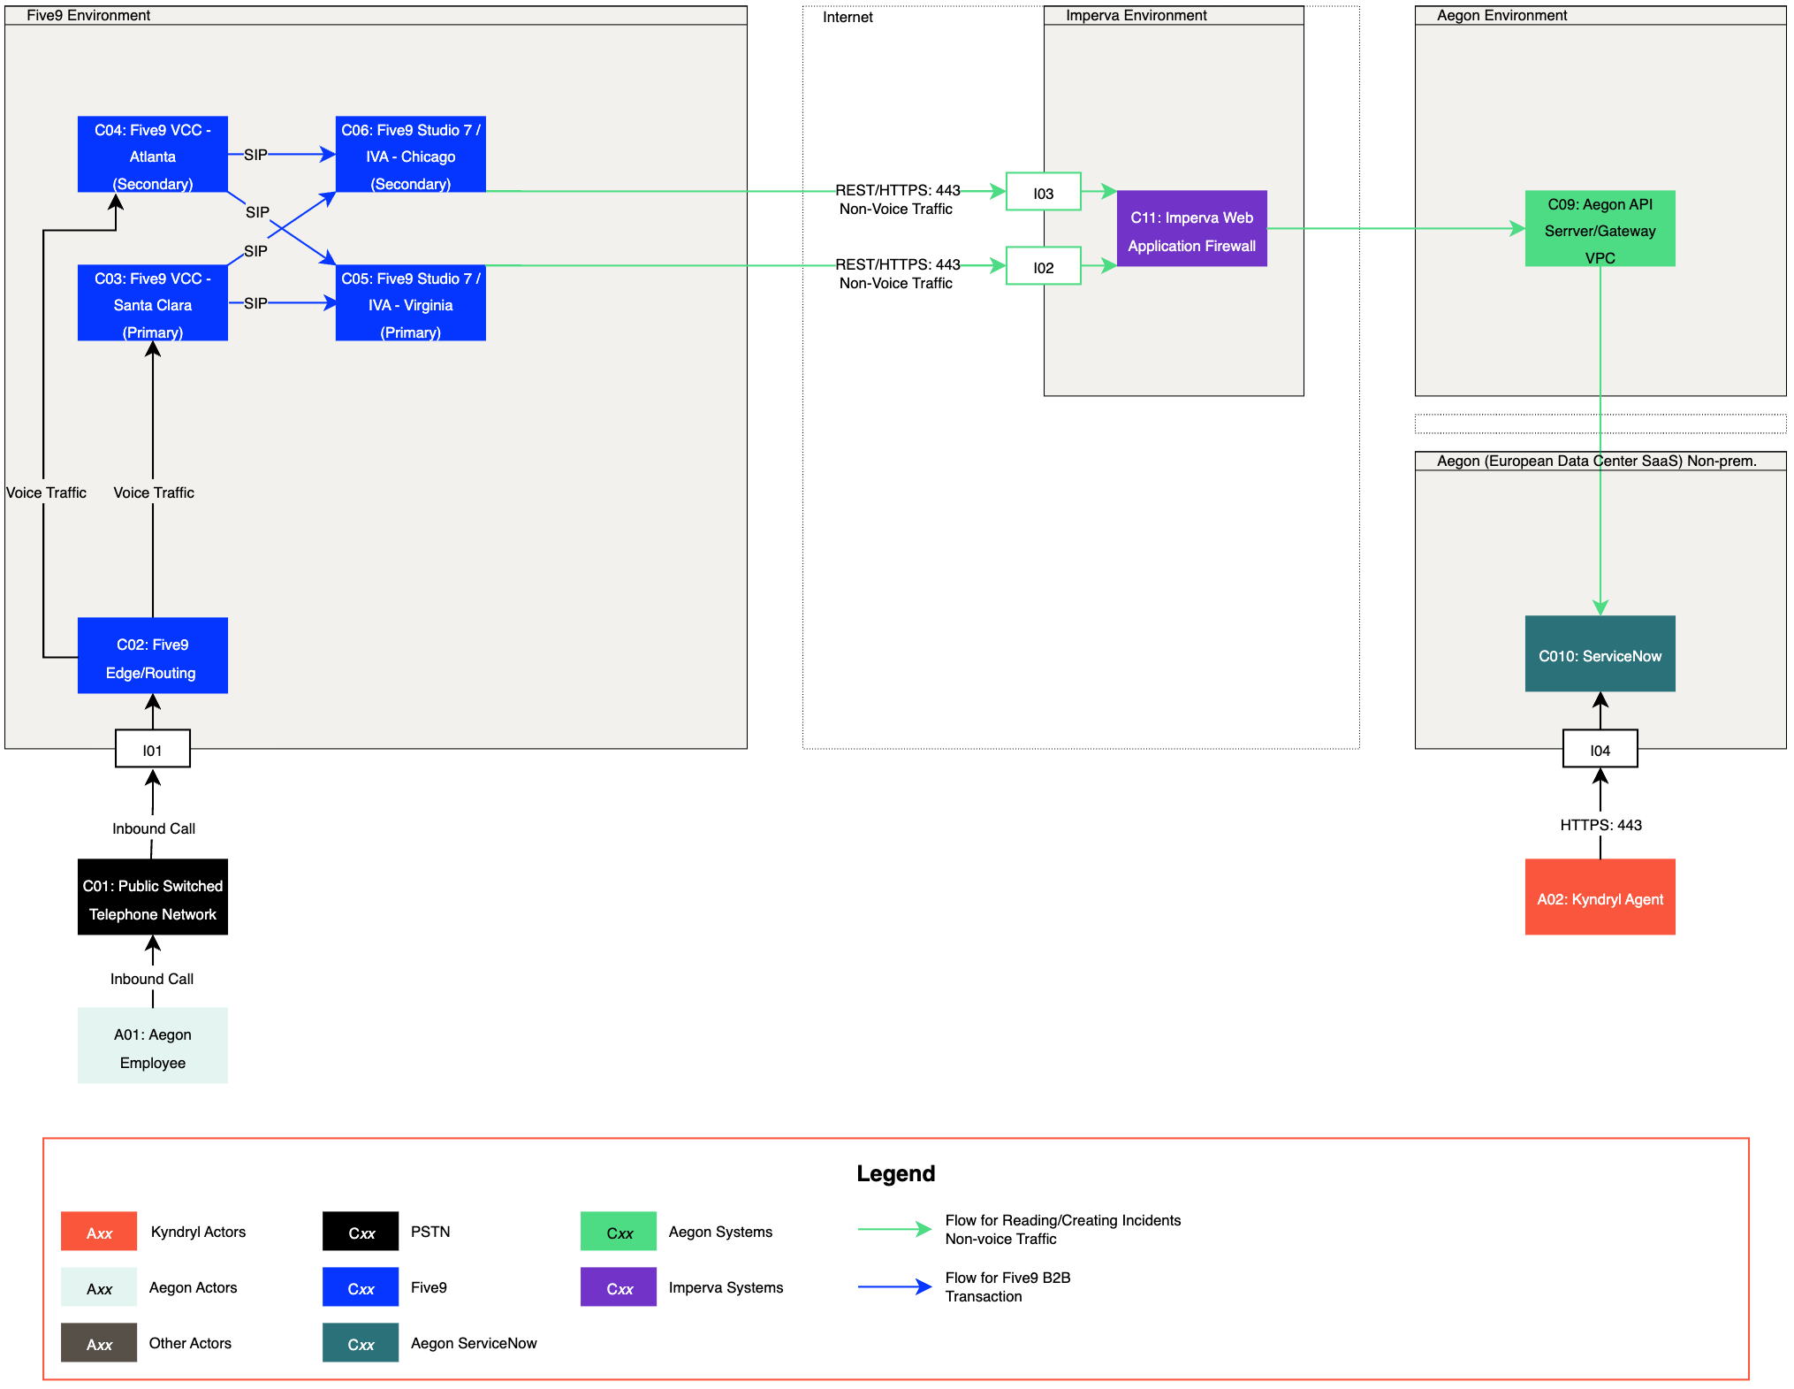
Figure 3 – Component Diagram (Option 1)

Reference | Name of Actor | Description | Attributes
A01 | Aegon Employee | This actor makes an inbound call to obtain support from the Kyndryl Service Desk.
A02 | Kyndryl Agent | This actor provides support to A01: Aegon Employee using C10: ServiceNow.
Figure 4 – Actors Table

Reference | Name of Component | Description | Attributes
C01 | Public Switched Telephone Network | This component provides the phone network that uses physical infrastructure to connect phone calls.
C02 | Five9 Edge/Routing | This component manages the routing of voice traffic to C03: Five9 VCC – Santa Clara (Primary) and C04: Five9 VCC - Atlanta (Secondary). | Sandbox  https://aegonsandbox.service-now.com/api/now/table/{tableName}  DEV  https://aegondev.service-now.com/api/now/table/{tableName}  MODEL  https://aegonmodel.service-now.com/api/now/table/{tableName}  PROD  https://aegon.service-now.com/api/now/table/{tableName}
C03 | Five9 VCC- Santa Clara (Primary) | This component provides the infrastructure for deploying and managing IVAs alongside remote contact center agents. It integrates with C05: Five9 Studio 7 / IVA – Virginia (Primary) and C06: Five9 Studio 7 / IVA – Chicago (Secondary) to enable intelligent virtual assistances (IVAs) with the cloud-based contact center. SIP (Session Initiation Protocol) is used to connect these respective environments. | - Encryption: Data is encrypted in transit and at rest.  - Component Physical Location: Santa Clara  - US IP Ranges  - 38.107.71.0 - 38.107.71.255  - 162.213.152.0 - 162.213.153.255  - 198.105.200.0 - 198.105.201.255  - 198.105.206.0 - 198.105.206.255  - Standard IP Subnets  - 38.107.71.0/24 SCL  - 162.213.152.0/23 SCL  - 198.105.200.0/23 SCL  - 198.105.206.0/24 SCL  - Additional Information: Five9 IP Address Ranges
C04 | Five9 VCC- Atlanta (Secondary) | This component provides the infrastructure for deploying and managing IVAs alongside remote contact center agents. It integrates with C05: Five9 Studio 7 / IVA – Virginia (Primary) and C06: Five9 Studio 7 / IVA – Chicago (Secondary) to enable intelligent virtual assistances (IVAs) with the cloud-based contact center. SIP (Session Initiation Protocol) is used to connect these respective environments. | - Encryption: Data is encrypted in transit and at rest.  - Component Physical Location: Atlanta  - US IP Ranges  - 198.105.202.0 - 198.105.203.255  - 198.105.207.0 - 198.105.207.255  - 208.69.28.0 - 208.69.29.255  - Standard IP Subnets  - 198.105.202.0/23 ATL  - 198.105.207.0/23 ATL  - 208.69.28.0/23 ATL  - Additional Information: Five9 IP Address Ranges
C05 | Five9 Studio 7 / IVA - Virginia (Primary) | This component allows for the creation and management of intelligent virtual agents (IVAs). It contains the scripting needed to submit requests to view create incidents. It integrates with C03: Five9 VCC – Santa Clara (Primary) and C04: Five9 VCC – Atlanta (Secondary) to enable intelligent virtual assistances (IVAs) with the cloud-based contact center. SIP (Session Initiation Protocol) is used to connect these respective environments. | - Encryption: Data is encrypted in transit and at rest.  - Component Physical Location: Virginia  - US IP Ranges  - Primary IP: 199.189.191.86  - Secondary IP: 199.189.191.146  - Primary IP (PCI): 199.19.68.222
C06 | Five9 Studio 7 / IVA - Chicago (Secondary) | This component allows for the creation and management of intelligent virtual agents (IVAs). It contains the scripting needed to submit requests to view create incidents. It integrates with C03: Five9 VCC – Santa Clara (Primary) and C04: Five9 VCC – Atlanta (Secondary) to enable intelligent virtual assistances (IVAs) with the cloud-based contact center. SIP (Session Initiation Protocol) is used to connect these respective environments. | - Encryption: Data is encrypted in transit and at rest.  - Component Physical Location: Chicago  - US IP Ranges  - Primary IP: 199.189.190.142  - Primary IP (PCI): 199.189.190.142
C07 | Five9 Mutual Authentication Proxy | The Five9 Mutual Authentication Proxy service enables mutual authentication utilizing  customer-provided certificate information. The Mutual Authentication Proxy is also used by the customer to replace certificates as they expire. | - Encryption: Data is encrypted in transit.  - Component Physical Location: Google Cloud Platform US  - GCP IP Address for Egress  - 35.239.61.221
C08 | Five9 Mutual Authentication Proxy | The Five9 Mutual Authentication Proxy service enables mutual authentication utilizing  customer-provided certificate information. The Mutual Authentication Proxy is also used by the customer to replace certificates as they expire. | - Encryption: Data is encrypted in transit.  - Component Physical Location: Google Cloud Platform US  - GCP IP Address for Egress  - 35.239.61.221
C09 | Aegon API Server/Gateway VPC | This component is used to receive API calls originating from the Five9 environment. | - Encryption: Data is encrypted in transit.  - Component Physical Location: TBD  - US IP Ranges  - 18.209.239.56
C10 | ServiceNow | This component is the ITSM system that provides data to and collects input from the IVA. Incidents are viewed and interactions are created within this component.
C11 | Imperva Web Application Firewall | This component is a SaaS solution providing a Web Application Firewall to the Amex Environment. | - Encryption: Data is encrypted in transit.  - Component Physical Location: https://www.imperva.com/products/global-network-map/  - URL: api-dev.aegon.com  - Reference: api-dev.aegon.cpm <CNAME> mwd9ehp.ng.impervadns.net
Figure 5 – Component Table

Reference | Name of Interface | Description | Data Exchange
I01 | C01: Public Switched Telephone Network to C02: Five9 Edge/Routing | This interface connects C01: Public Switched Telephone Network to C02: Five9 Edge/Routing. | - Function: The data exchanged consists of voice traffic originating from A01: Aegon Employee.  - Connection/Initiation: A01: Aegon Employee initiates a call across C01: Public Switched Telephone Network to C02: Five9 Edge Routing.
I02 | C07: Five9 Mutual Authentication Proxy to C11: Imperva Web Application Firewall | This interface connects C07: Five9 Mutual Authentication Proxy to C11: Imperva Web Application Firewall. | - Function: The data exchanged supports the viewing and creation of incidents and data within C10: ServiceNow via REST API on C09: Aegon API Server/Gateway VPC.  - Connection/Initiation: Five9 Studio 7 / IVA - Virginia (Primary) or Five9 Studio 7 / IVA - Chicago (Secondary) initiates a connection across C07: Five9 Mutual Authentication Proxy to C11: Imperva Web Application Firewall.  - Encryption: Web traffic is encrypted in transit using TLS1.2 (HTTPS: 443).  - Authentication and Authorization: Authorization request to C09: Aegon API Server/Gateway VPC is then granted via OAuth.
I03 | C08: Five9 Mutual Authentication Proxy to C11: Imperva Web Application Firewall | This interface connects C08: Five9 Mutual Authentication Proxy to C11: Imperva Web Application Firewall. | - Function: The data exchanged supports the viewing and creation of incidents and data within C10: ServiceNow via REST API on C09: Aegon API Server/Gateway VPC.  - Connection/Initiation: Five9 Studio 7 / IVA - Virginia (Primary) or Five9 Studio 7 / IVA - Chicago (Secondary) initiates a connection across C08: Five9 Mutual Authentication Proxy to C11: Imperva Web Application Firewall.  - Encryption: Web traffic is encrypted in transit using TLS1.2 (HTTPS: 443).  - Authentication and Authorization: Authorization request to C09: Aegon API Server/Gateway VPC is then granted via OAuth.
I04 | A02: Kyndryl Agent to C10: ServiceNow | This interface connects A02: Kyndryl Agent to C10: ServiceNow. | - Function: The data exchanged supports the management of incidents within C10: ServiceNow.  - Connection/Initiation: A02: Kyndryl Agent initiates the connection to C10: ServiceNow.  - Encryption: Web traffic is encrypted in transit using TLS1.2 (HTTPS: 443).  - Authentication and Authorization: Authentication is handled through Kyndryl Single Sign-On (SSO) . Authorization to use C10: ServiceNow is granted/managed by the ServiceNow administrator through the system’s access control list (ACL).
Figure 6 – Interface Table

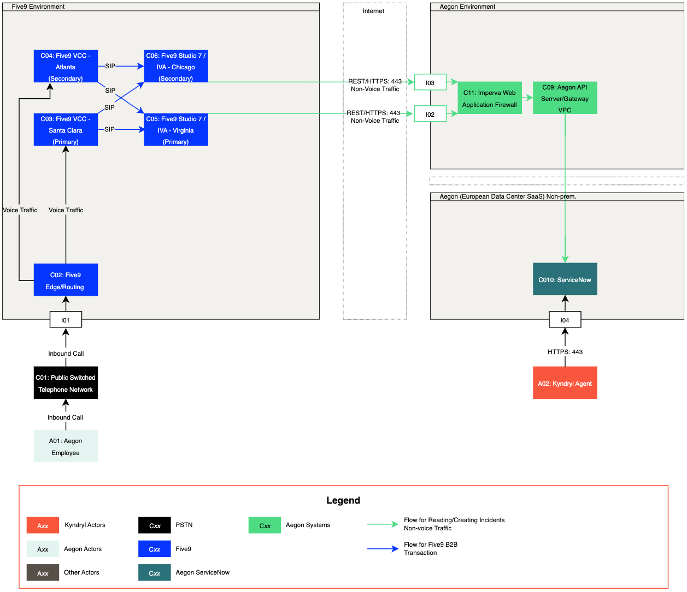
Figure 7 – Component Diagram (Option 2)

SN API Endpoint and Data

Operation: Trigger Azure Radius Authentication

The request will trigger Azure Radius authentication through Microsoft Authenticator App.

POST https://accesskd-test.aegon.com
Request Headers
- username
  - User ID captured by user
- domain
  - Static value set to us
- mfamethod
  - Static value set to azure
Response Parameters
Name | Mandatory | Nullable | Description | Schema
result | Y | N | Result set  {  "username": "user ID",  "identity": "false",  "sessionid": "e49cadb0"  } | JSON list

Operation: Get User Sys_id

The request will retrieve the user sys_id.

GET /now/table/sys_user
Request Parameters
- sysparm_query
  - Query By: User ID
Response Parameters
Name | Mandatory | Nullable | Description | Schema
result | Y | N | Result set {  user_name, first_name, last_name , sys_id,  etc…} | JSON list

Operation: Create Interaction

The request will create an interaction in SN using the following endpoint.

POST /now/table/interaction
Request Parameters
Required | Name | Located in
Y | opened_for | Json Data
Y | short_description
Y | work_notes
Y | u_description
Y | type
Y | state
Y | assignment_group

Response Parameters
Name | Mandatory | Nullable | Description | Schema
result | Y | N | Result set {  number, etc...  } | JSON list

Operation: Get Incident list

The request will fetch the list of Incident in SN for a specific user under specific states using the following endpoint.
GET /now/table/incident

Request Parameters
  - caller_id.name
  - sysparm_query
    - Query By: state

Response Parameters
Name | Mandatory | Nullable | Description | Schema
result | Y | N | Result set {  number, etc..  } | JSON list

Note: Please provide the current state Id for each ticket state involved. (For instance, Resolved => 6)
State | State Id
Resolved | 6
New | 1
In Progress | 2
On Hold | 3

Operation: Get Incident

The request will fetch the details of an incident in SN using the following endpoint.

GET /now/table/incident
Request Parameters
- sysparm_query
  - Query By: number
Response Parameters
Name | Mandatory | Nullable | Description | Schema
result | Y | N | Result set {  number, sys_id, state, short_description, Description, assignment_group.value, etc...  } | JSON list

Operation: Get Additional Comments

The request will retrieve the additional comments related to a specific Incident.
GET /now/table/sys_journal_field

Request Parameters
- sysparm_query
  - Query By: element_id
  - Element=comments
Response Parameters
Name | Mandatory | Nullable | Description | Schema
result | Y | N | Result set {  value, etc…  } | JSON list

Operation: Get Assignment Group

The request will get the name of the assignment group in SN using the following endpoint.
GET /now/table/sys_user_group

Request Parameters
- Group_sys_id
Name | Mandatory | Nullable | Description | Schema
result | Y | N | Result set {  name, etc...  } | JSON list
Response Parameters

Access Control Lists

This section outlines simple rules for access to data that we will follow. These rules can be enforced by the Web Service by creating access control lists (ACLs). An ACL specifies which users are granted access to objects, as well as what operations are allowed on given objects.

Object Rules
- The object name is the table name that requires access.
- create allows inserting new records (rows) into a table.
- read allows querying records from a table.
- write allows updating records in a table.

Object name | Create | Read | Update
incident |  | X
sys_user_group |  | X
sys_user |  | X
sys_journal_field |  | X
interaction | X

For access to the Additional Comments:
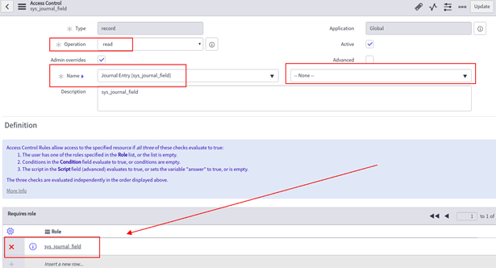

Deployment Model
Workflow for the IVR automation development and deployment
1. In the Development environment, developers will code and configure the call flows in the IVR system.
2. Once these scripts and call flows are validated and approved, Integration specialists will conduct additional testing in the UAT environment.
3. Following testing, Integration specialists will transfer the scripts to the Pre-Production environment for final testing with the platform engineers.
4. Platform engineers will ensure the proper deployment of these scripts and call flows.

Figure 4 – Deployment Model Diagram
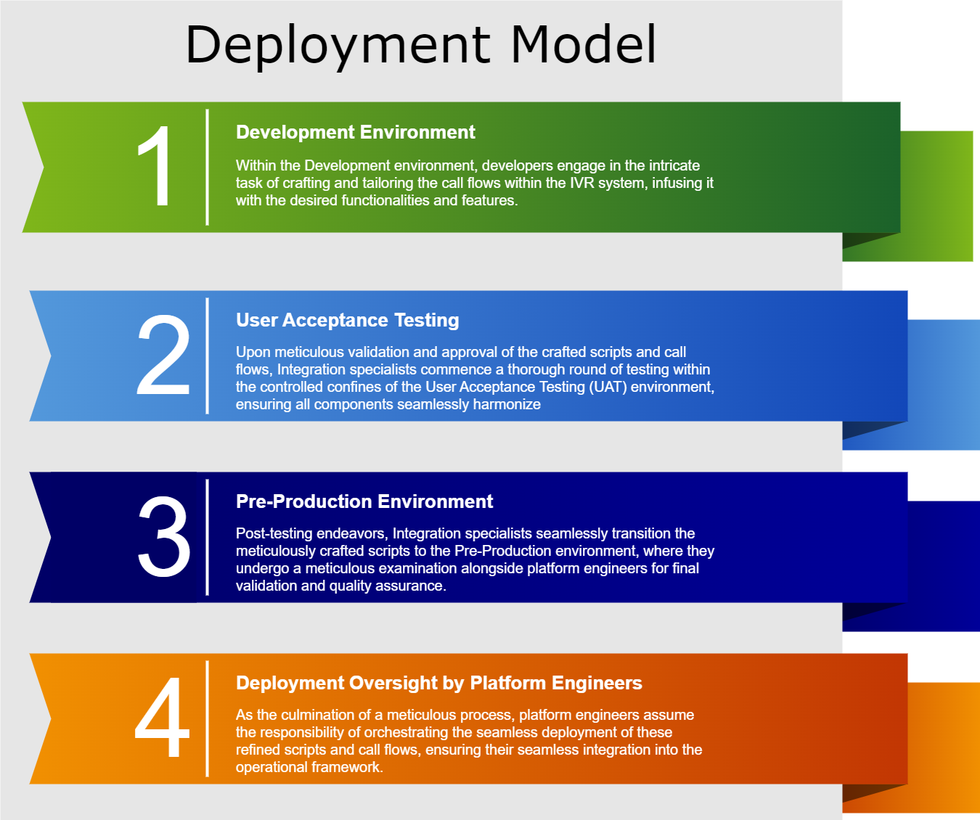

Technology Components
Technology Component Type | Technology Component Name | CMDB ID | Architecture Impact | Tech Lifecycle Strategy | Application Risk Rating
Software | Azure Radius Authentication | New | Reuse | Buy | TBC
Software | ServiceNow Integration (SN) | CI002457504 | Reuse | Hold | TBC
Software | Google DialogFlow Integration | New | New | Buy | TBC
Software | Five9 Agent Desktop | CI035066003 | Reuse | Hold | TBC
Software | Five9 VCC | CI035066003 | Enhance | Reuse | TBC
Software | Studio 7 | New | New | Buy | TBC
Note: CMDB IDs for new components have been requested.

